**2019.3.14-2019.3.19（The 3st week）**

**Achievement:**

**Item1 Paper reading:**

**Title:** DNPU: An 8.1TOPS/W Reconfigurable CNN-RNN Processor for General-Purpose Deep Neural Networks（ISSCC 2017 14.2）

**Current situation:** The computational requirements in CNNs are quite different from those of RNNs. It’s not practical to accelerate FCLs and RLs with SoCs specialized for CLs , or accelerate CLs with FCL- and RL-dedicated SoCs. A highly reconfigurable CNN-RNN processor with high energy-efficiency is desirable to support general-purpose deep neural networks.

**Contributions：1)** the first CNN-RNN SoC with the highest energy efficiency **2)** a LUT-based reconfigurable multiplier optimized for the dynamic fixed-point with on-chip adaptation via overflow monitoring to exploit maximum efficiency from kernel reuse in the CP **3)** a quantization table (Q-table)-based matrix multiplication to reduce off-chip memory access and remove duplicated multiplications in the FRP.

**Overall architecture:**

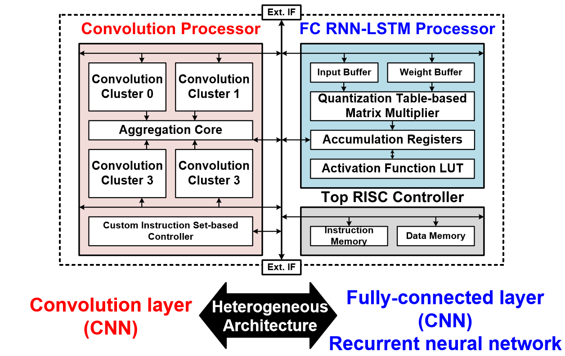

This chip consists of three parts: CP, FRP and a top RISC controller. The CP is composed of 4 convolution clusters and 1 aggregation core. Each convolution cluster performs convolution operation cores., and transfers the accumulation results to the accumulation core. One convolution core contains 4 PE groups with 48 PEs. The FRP performs matrix multiplication with the 128-enty Q-table, and 8 16b fixed-point multipliers are used to update the Q-table. The CP and FRP are able to process 4 different CLs and 8 RLs respectively, in parallel.

**Chip Specifications**:

|  |  |  |  |  |  |  |  |  |
| --- | --- | --- | --- | --- | --- | --- | --- | --- |
| Technology | 65nm 1P8M CMOS | | | | | | | |
| Chip size | 4*4mm2 | | | | | | | |
| Gate count | \ | | | | | | | |
| On-chip Memory | CLP(280KB) FCRLP(10KB) | | | | | | | |
| Supply voltage | 0.77~1.1V | | | | | | | |
| Operating Frequency | CLP | | FCRLP | | NoC | | | ETC |
| ~200MHz | | ~200MHz | | ~400MHz | | | ~200MHz |
| Power Consumption |  | | CLP | FCRLP | | | ETC | Total |
| [50MHz@0.77V](mailto:50MHz@0.77V) | | 29mW | 2.6mW | | | 3mW | 34.6mW |
| 200MHz@1.1V | | 235mW | 21mW | | | 23mW | 279mW |
| Energy Efficiency |  | CLP Word Length:16 bit | | | | CLP Word Length:4 bit | | |
| 50MHz@0.77V | 2.1TOPS/W | | | | 8.1TOPS/W | | |
| 200MHz@1.1V | 1.0 TOPS/W | | | | 3.9TOPS/W | | |

**Summary**:

**Advantages**:1) the only one that supports both CNNs and RNNs

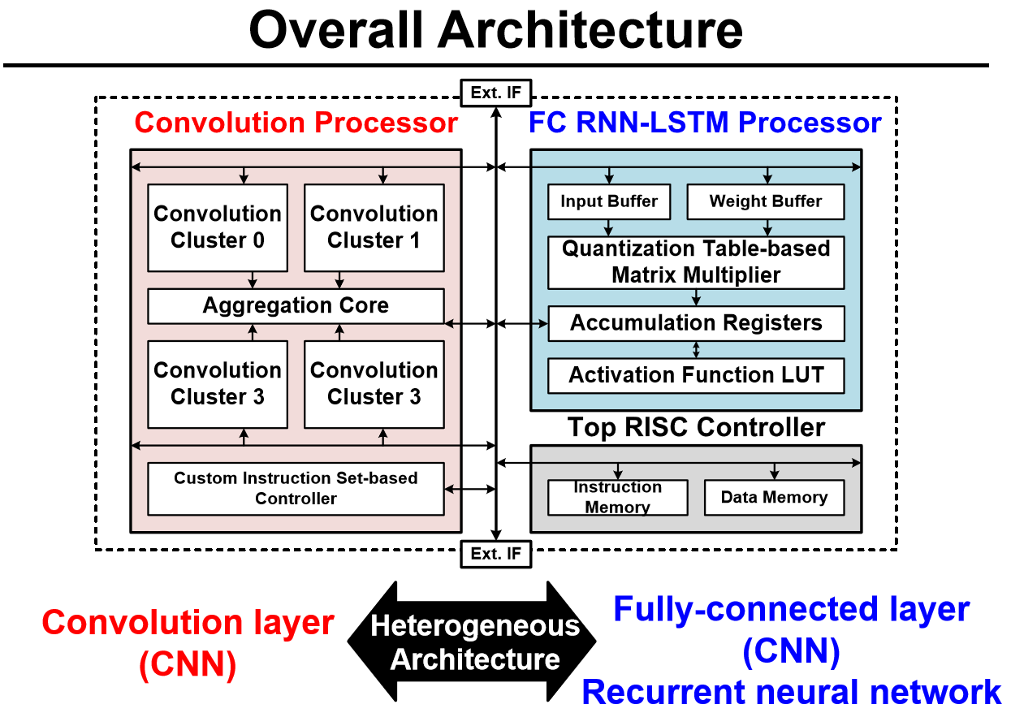

2)propose input-layer mixed division method to save bandwidth and minimize off-chip memory access

**Item2 Tanji3 documentation:**

Finish the checkout (literal expression and graphs) of Part 2.5-2.6

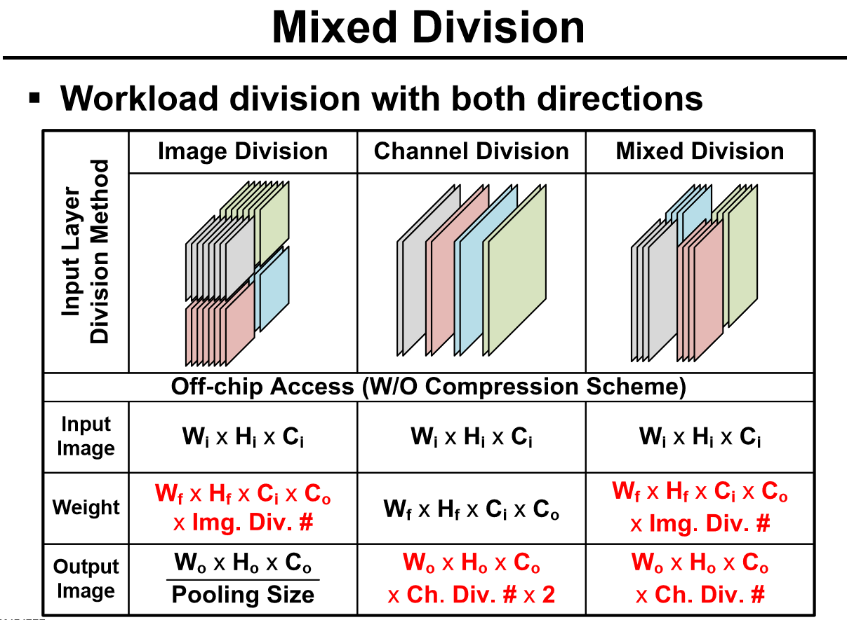

3) propose dynamic fixed-point with on-line adaption architecture to minimize the off-chip memory access of filter at a low accuracy loss

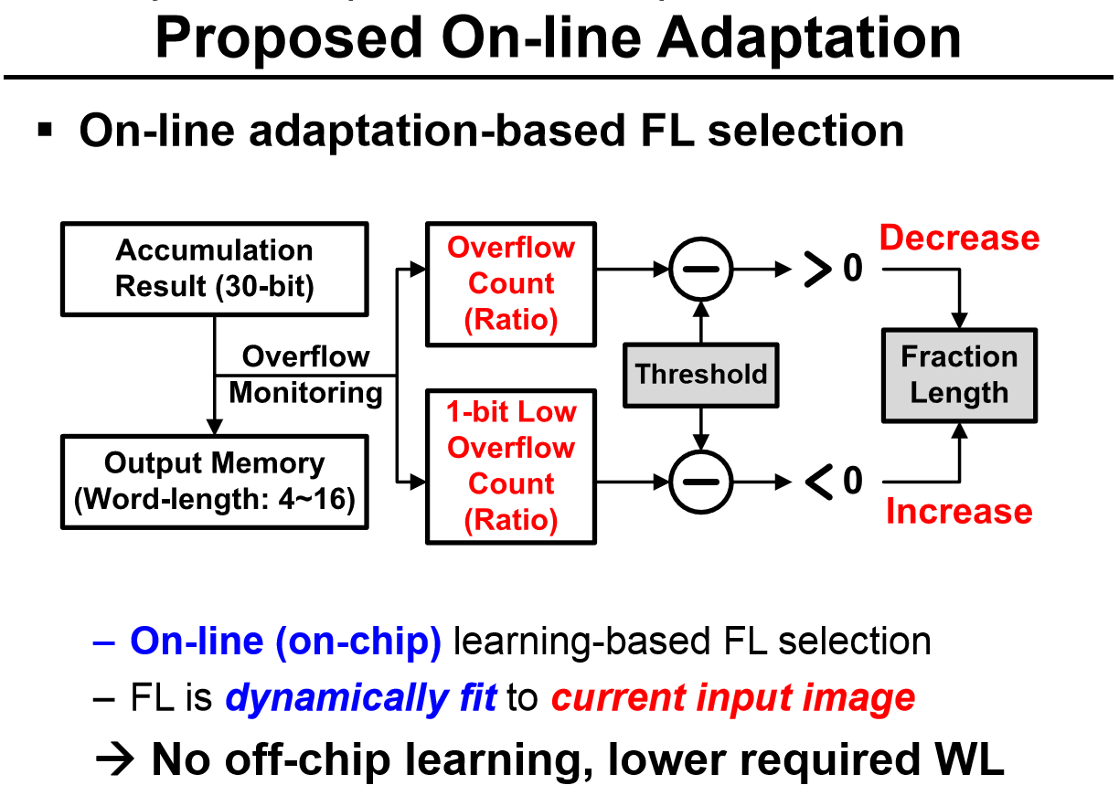

4) propose Quantization Table-based Multiplier to minimize off-chip accesses

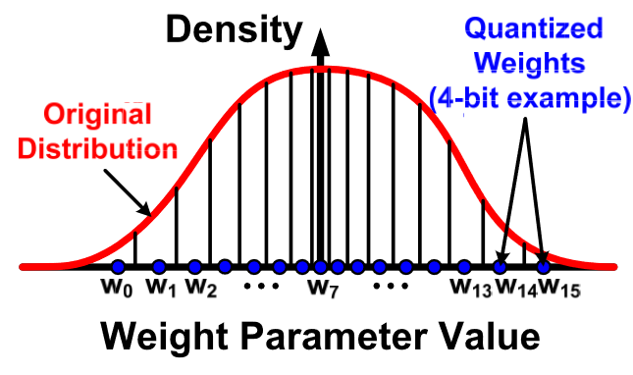

**Shortcomings:**1) No details about on-chip adaptation with overflowing monitoring for accumulation

**Plan next week:**

Item1: Item2: Paper reading.

Item2: Use Verilog to write some simple modules for practice.

Item3: Learn MIPs computer architecture.

**2019.3.7-2019.3.12（The 2nd week）**

**Achievement :**

**Item1 Paper reading:**

**Title:** A 1.42TOPS/W Deep Convolutional Neural Network Recognition Processor for Intelligent IoE Systems（ISSCC 2016 14.6）

**Current situation:** It’s not practical to transmit data acquired by IoE(Internet-of-Everything) device to data center for process, doing in-situ processing of data can be more efficient, in which situation application-specific accelerator is of immediate use.

**Contributions：**1)a CNN-optimized neuron processing engine(NPE) 2) a dual-range multiply-accumulate(DRMAC) block for low-power convolution operations, 3) an on-chip memory architecture and a utilization scheme for reducing off-chip memory access, 4)kernel data compression for further reducing off-chip memory access

**Overall architecture:**

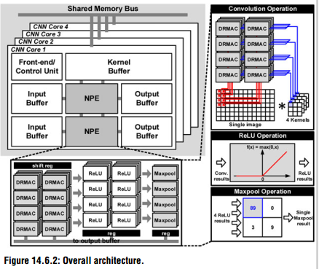

There are four homogeneous CNN cores in the chip，each core contains 2NPEs, 2 image buffers, 2 output buffers and a kernel buffer. The NPE consists of 32 MACs, 32 ReLU, 8 Maxpool blocks, used for multiply/accumulate, nonlinear and pooling process respectively, these blocks can operate in parallel to exploit data-level parallelism.

**Chip Specifications**:

|  |  |
| --- | --- |
| Technology | 65nm 1P8M CMOS |
| Chip size | 4*4mm2 |
| Gate count | 3.2M Logic Gates |
| On-chip Memory | 36KB |
| Supply voltage | 1.2V(core)/3.3V(IO) |
| Clock rate | 125MHz |
| Peak throughput | 64GOPS |
| Arithmetic precision | 24b fixed-point |
| Targeted benchmark | MNIST,CIFAR-10,GTSRB,AlexNet |

**Summary**:

**Advantages**:1) ReLU and Maxpool blocks are turned off until convolution operations are finished to **save power** 2) 4 groups of 8 MACs share a input feature map to **reuse ifmap** and **save bandwidth** 3) dual range multiply-accumulate to **save power** 4) switch the roles of input buffer and output buffer to the opposite to **avoid off-chip memory access**, similar to this, Tanji3 use global buffer to store both ifmap and ofmap to avoid off-chip memory access 5) use off-chip principle component analysis to get basic kernels, only transmit basic kernels to chip and generate constant kernels on-chip to **save off-chip memory access**

**Shortcomings:**1) No mention about NPE use ratio.

**Item2 Tanji3 documentation:**

Finish the checkout (literal expression and graphs) of Part 2.4 Global buffer.

**Plan next week:**

Item1: Go on with the checkout of Tanji3 documentation with Part 2.5-2.6.

Item2: Paper reading.

Item3: Use Verilog to write some simple modules for practice.